LCD-S886- Instructions

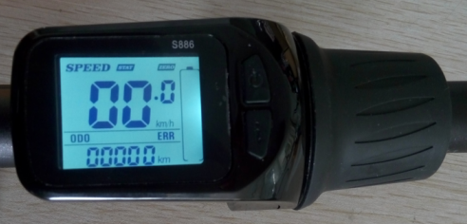

- Appearance size and Material
The outer shell of the product is ABS and the transparent window is imported high hardness acrylic, the hardness value is equivalent to tempered glass.
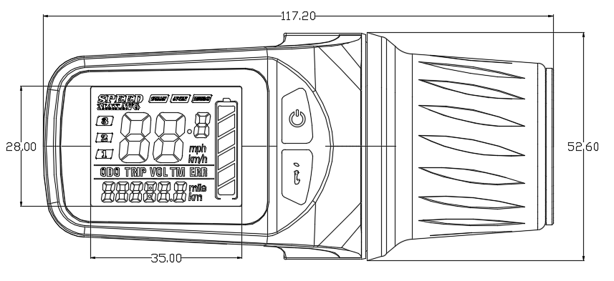

Front view

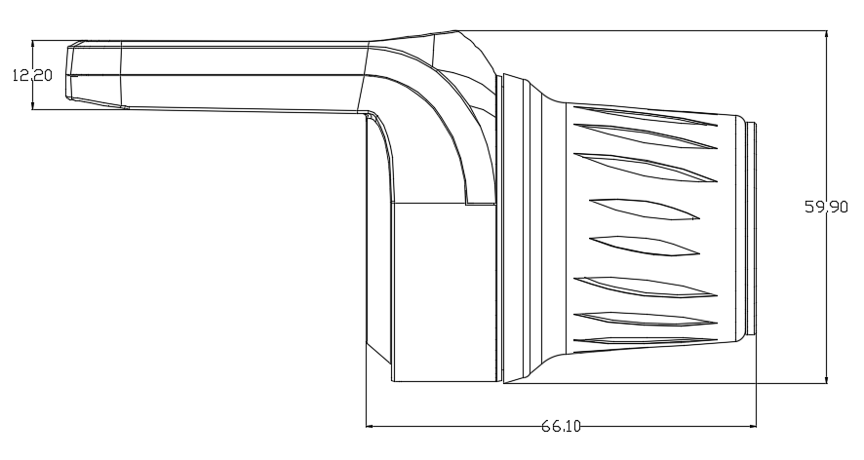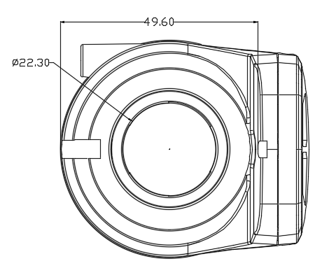
Side view Shifter support
- Working voltage and Connection mode
2.1 Working voltage：DC24V、36V、48V、60V Compatibility；
Other voltages can be customized.

2.2 Connection mode：

Wiring sequence of standard connectors
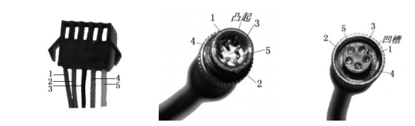
Connect to the controller Instrument outlet part docking part

Chart: List of wiring sequence of standard connectors
Wiring sequence of standard connectors | Color | Function
1 | Red(VCC) | Instrument power cord
2 | Blue(K) | The power line of the controller
3 | Black(GND) | Instrument ground wire
4 | Green(RX) | The data receiving line of the instrument
5 | Yellow(TX) | The data sending line of the instrument

Note: the leads of some products are waterproof connectors. Users cannot see the color of the leads in the wire harness.
- Functional specification
Function：

3.1 Display function
Speed display, power indicator, fault prompt, total mileage, single mileage.
3.2 Control and Setting function
Power switch control, wheel diameter setting, Idle automatic sleep time setting, backlight brightness setting, starting mode setting, driving mode setting, voltage level setting, controller current limit value setting.
3.3 Communication protocol：UART
All contents of the Display screen（Full display within 1S after boot）.
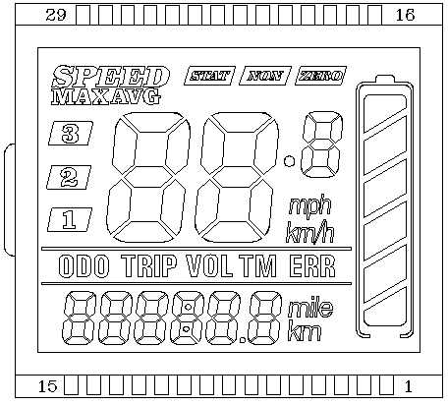
Introduction to Display content
3.3.1 Voltage state level POWER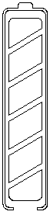

3.3.2 Multifunctional display area 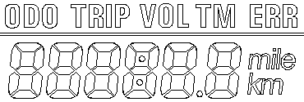
ODO（Unit：mile、km）、TRIP、current voltage VOL、run time TM、fault codes ERR
Fault Codes (Decimal) | Fault state | Notes
E02 | Brakes
E06 | Low battery voltage
E07 | Motor fault
E08 | Shifter fault
E09 | Controller fault
E10 | Communication reception fault
E11 | Communication send fault

3.3.3 Speed display area 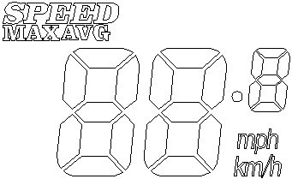
Unit: mph, km/h
The speed signal is taken from the motor inner hall signal and sent to the instrument by the controller,（The time of a single Hall period, Unit： 1MS） The instrument calculates the true speed from the wheel diameter and signal data (The motor hall also needs to set the number of magnetic steels).
Current speed; Max speed; Average speed.
3.3.4 Vehicle power gear adjustment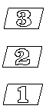, It is adjustable in 1-3 gears.
3.3.5 Zero, Non-zero start display area；
shows Zero start, shows Non-zero start；
- Settings
P01: Backlight intensity , the darkest is level 1，the brightest is level 3;
P02: Mileage unit，0: km; 1: mile;
P03: Voltage classes：24V，36V，48V，default: 36V；
P04: Sleep time: 0, don’t sleep; other figures are sleep time; Range：1-60; Unit: minute;
P05: Power gear: 0: 3gears mode;
P06: The wheel diameter: unit: inch; precision: 0.1;
P07: Speed measurement of magnetic steel number: Range: 1-255;
P08: The speed limit: Range 0-100km/h，100 means no speed limit;
1.Communicate status（Controller control）: The input data here represents the maximum running speed of the vehicle: For example, enter 25, means the maximum running speed of the vehicle will not exceed 25km/h; the drive speed is maintained at the set value;
Error：±1km/h；（Power, Shifter all limit speed）
Note：the value here is based on kilometers. When the unit set is convert from kilometers to miles, the speed value of the display interface will automatically convert to the correct value of miles. However, the speed limit value data set in this menu under the mile interface is not converted, which is inconsistent with the actual speed limit value displayed;
Notice：P09-P15 menu is valid only in the communication state.

P09: Zero start、Non-zero start setting, 0: Zero start; 1: Non-zero start；
P10: Drive mode setting: 0: Power drive (How much power is output is determined by the power tap, and shifter is invalid at this time).
1: Electric drive (through the shifter drive, power gear is invalid at this time).
2: Power drive and electric drive coexist (power gear and shifter drive both work).

P11: Power sensitivity setting 1-24;
P12: Power start intensity setting 0-5;
P13: Power magnetic steel disk type setting 5，8，12grain magnetic steel type;
P14: Set the current limit of the controller, default: 12A , range: 1-20A;
P15: Controller under-voltage value;
P16: ODO Reset , long press the button to clear ODO for 5 seconds；
P17: 0: Cannot make a cruise, 1: Can make a cruise; Automatic cruise optional (valid for Protocol 2 only)
P18: Display speed proportional adjustment Range: 50%~150%;
P19: Gear 0, 0: containing 0 gear, 1: not containing 0 gear;
P20: 0: Protocol 2; 1: Protocol 5S; 2: standby 3: standby

- Button introduction：
5.1 When it is power-off state, long press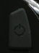button to start; after start, short pressbutton, interface will switch in ODO、TRIP、VOL、TM、ERR.
5.2 When it is power-on state, long pressbutton to close, and short press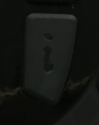button to adjust the power gear.
5.3 Long press+button enter into mode setting. In the setting interface, short pressbutton to switch parameter, long pressbutton to switchbutton’s function of add/subtract;
Parameter modification：In some parameter state，short pressbutton to switch parameter, short pressbutton to add or subtract value. After modification，short pressbutton to switch to the next parameter, and save the previous parameter value; after parameter modification, long press+button again to exit setting interface or wait 8 seconds to automatically exit and save the parameters.

5.4 Crank adjusts the motor speed, and the motor speed increases by turning from top to bottom; and let it go then return to zero.

