User’s Manual
Model: Zipper Z6AH26
1. Safety instructions and notes
1.1 Safety instructions
1.2 Notes
2. Basic structure and name
3. Assembly method and requirements
3.1 Installation of headlight and front fender
3.2 Installation of front wheel
3.3 Installation of front brake
3.4 Installation of steering handle
3.5 Installation torque for all parts
4. Operation and adjustment
4.1 Introduction of power assistant system
4.2 Charging
4.3 Adjustment of quick release parts
4.4 Reflection and lightening system
4.5 Safety height mark
4.6 Braking system
4.7 Speed control system
4.8 Damping system
4.9 Rear rack
5. Use and maintenance
5.1 Routine inspection before use
5.2 Daily use, inspection and maintenance
6. Riding guidance troubleshooting

Electric-power- assistant bicycle, equipped with pedals and an auxiliary electric motor, which cannot be propelled exclusively by means of this auxiliary electric motor, except in the start-up assistance mode, and the start-up assistance speed is less than 6 km/h

Compared with bicycle, Electric bicycle only add motor, controller, charger, battery. When riding, electric power will make riding easier and save labor.
Items in carton:
When you open the carton, please check if the following items are inside. If not, please contact with your agent.

Electric bicycle 1 pc
Charger 1 pc
Pedal 1 pair
Manual 1 pc

- Safety instructions and notes
1.1 Safety instructions
Before carefully reading the Manual and understanding the performance of the electric bike, do not use the electric bike, and do not lend it to the persons who cannot handle the electric bike.
Preparations before riding: wear your helmet, gloves and other protective gears before riding to protect yourself from damage in case of an accident.
Cycling conditions: ambient temperature of -10℃ to 35℃,no wind and flat roads;
Max load: the max load of the electric bike is 100kg coupled with the max load (25kg) of the rear rack; Our company shall not undertake any responsibility if an accident happens when the load is more than 125kg.
In case of frequent brake, startup, uphill, headwind running, muddy roads, overload and others, a large quantity of electric power of the storage battery will be consumed, thus affecting the continued mileage, so we recommend that you avoid the above factors when riding.
If the storage battery is disabled for a long time, make sure to charge it enough, and it need be additionally charged once if its storage is more than a month.
Make sure to pay attention: the electric bike cannot wade for a long time because if water enters into the controller and motor wheel, it may cause short circuit to damage the electrical parts.
Prohibit unauthorized demolition or alteration, and our company shall not be responsible for any losses caused.
The waste battery cannot be discarded randomly, so as to avoid environmental pollution.
1.2 Notes
The electric bike is designed based on the original bike in combination with the market demand and is a means of transport with special functions and uses. At the time of purchase, please select and buy a model suitable for your need, and the drivers must have known driving technique before driving on the roads. In order for your correct use and security, please pay attention to the following matters:
- During your riding, please check whether motor and rear fork are well fastened, and tighten them timely.
- When turning on the power supply or coming across a slope during your riding, use the pedals to assist as far as possible to reduce the surge current and extend the battery life and continued range.
- In rainy days, when the water depth is higher than the wheel center, and the water is likely to soak into the motor, thus result in motor failure.
- Users must use the dedicated charger. When charging the battery, please put the battery and the charger in a stable and flat place.
- Please take the charging process in a good ventilation environment, and it is prohibited cover the battery box or charger with any things that may impede the heat dissipation.
- Please keep appropriate tire pressure so as to avoid increasing the friction between the tire and the ground, which may easily wears the tires and deforms the rim.
- Users should abide by traffic rules, and the riding speed should be below 25km/h and the goods carried on the rear rack should not exceed 25kg.
- Do not use the front brake during high-speed running or downhill riding, in order to avoid the center of gravity from moving ahead and lead to accidents.
- For safety-critical components failure, please purchase brand components, or contact the dealer for replacement.
- The EPAC bicycle is not suitable for installing a child-seat. If you need to use the child-seat please note precaution the children’s finger was trapped by the suspension saddle.
- Please note the gap on the sample in normal use and maintain process, to prevent entrapment presented.
- Basic structure and name
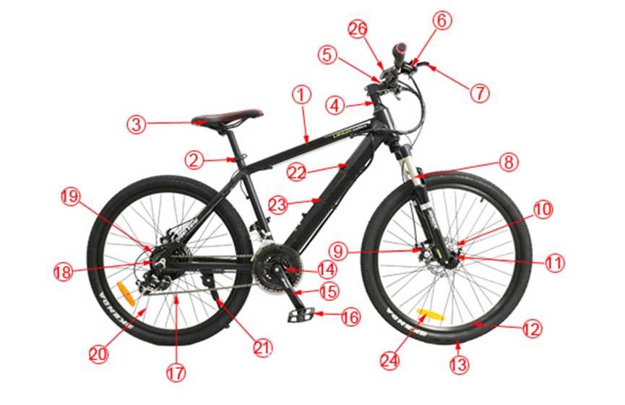 2.1 Z6AH26 basic structure and name
1.Frame 2.Saddle post 3.Saddle 4.Stem 5.Handle bar 6.Derailleur
7.Brake lever 8.Front fork 9.Disc brake 10. Disc brake plate 11.Hub
12.Rim 13.Tire 14.Speed sensor 15.Crank 16.Pedal 17.Chain
18.Flywheel 19.Motor 20.spok 21.Kick stand 22.controller 23.battery 24.Reflector
3. Assembly method and requirements
3.1 Installation of stem group
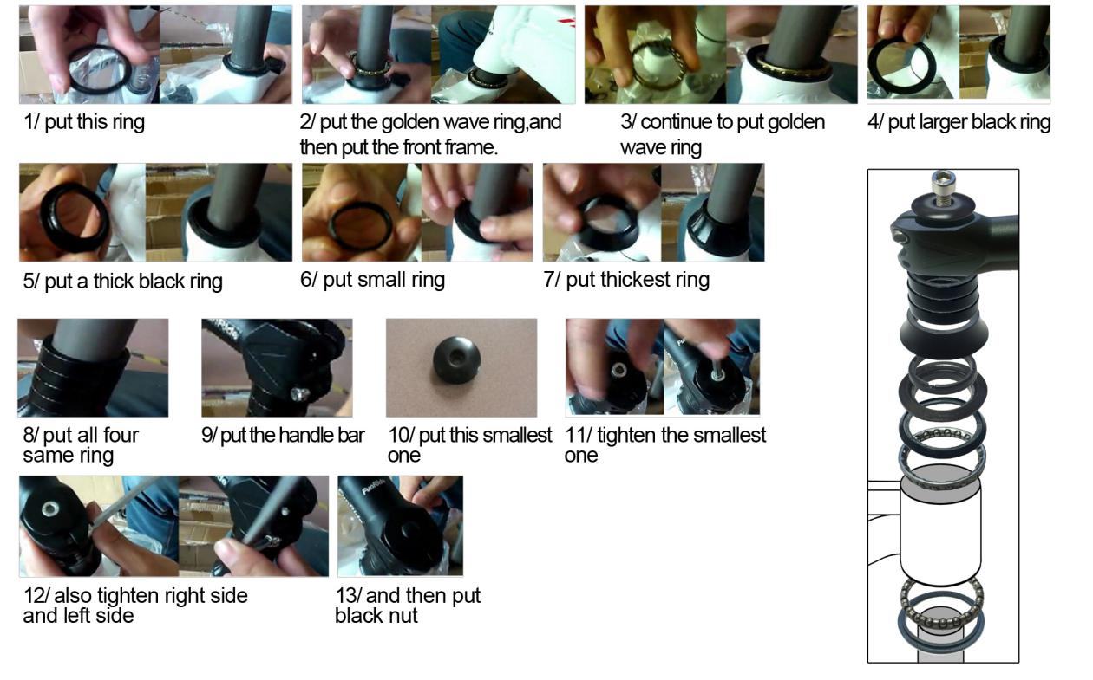
First check all parts in accordance with the picture successively set into the riser (Note the direction), insert the bolt from top and tighten the nut.
3.2 Installation of front wheel
3.2.1 Installation of common front wheel
- Take out Quick-release in front wheel, and loose the nut
- Get our a little spring
- Inset the center axle
- Adjust front wheel
- Lock of the Quick-release
- Finish installation
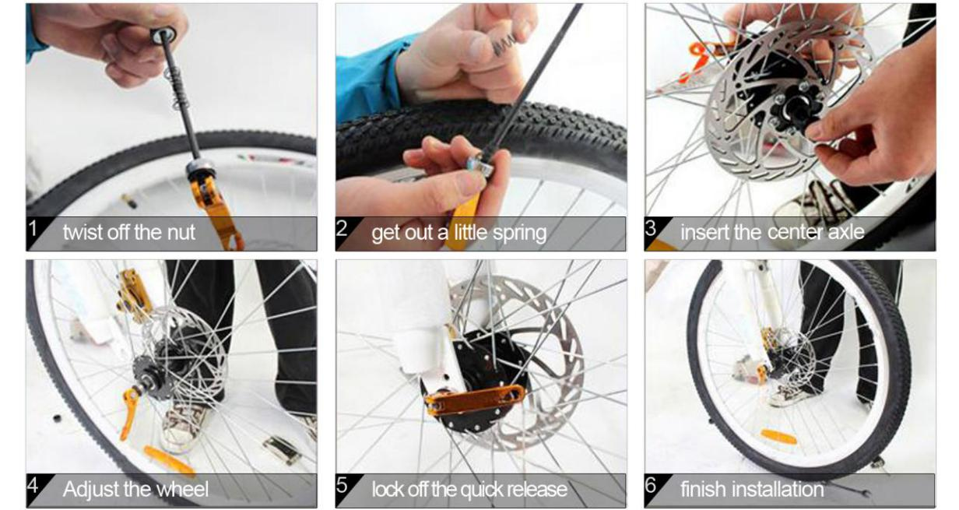

When fastening the nut for front wheel hub, press down the front fork appropriately so that the front wheel hub can work closely with the front fork.

3.2.2 Installing the brake cable
- Loosen the brake cable
- make brake device and the nut opening in lever
- Insert the cable
- Screw and tighten the nut
- Tighten and fix the cable
Position the cable equally on both sides of the rim. If not, please readjust the brake, refer to chapter
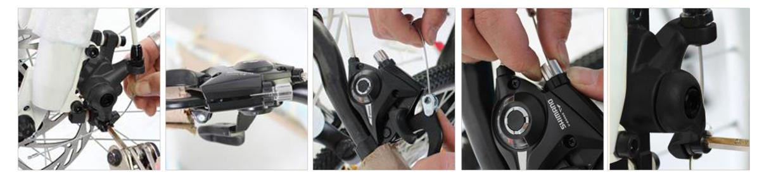

3.3 Installation of front brake
3.3.1 Mounting the rotor to the hub
1. Remove the wheel from the bike. Attach the rotor to the hub with the supplied Torx bolts and tighten with a T25 Torx wrench. Final tightening torque: 6.2 N.m.
2. Make the side with Tektro logo out (rotor must rotate same direction as wheel set). Tighten the rotor screw and then install the wheel on the front fork or frame.
Note: The rotor must be installed with the “rotation” arrows pointing in the same direction as the forward rotation of the wheel.

3.3.2Mounting the adapter and caliper
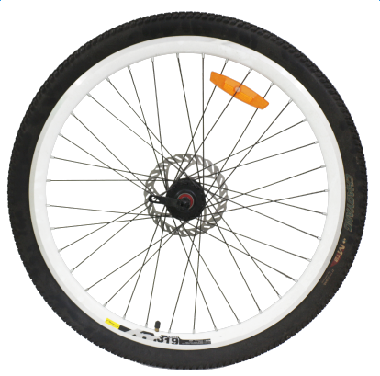

1. Mount the relevant adapter to the caliper body. Insert 5mm bolts through the two adapter slots on the body and screw into the holes on the adapter. Do not tighten yet.

2. Mount the caliper body and adapter to the frame/fork by placing the slot in the caliper body over the rotor. The mounting holes on the adapter should be behind the frame/fork mounting holes (the hub side). Screw and tighten two 5mm Allen bolts into the upper and lower holes in the frame/fork mount. Final tightening torque 6-8N.m.

3. Check that the rotor is centered between the disc brake pads and tighten the two bolts holding the caliper to the adapter. To re-adjust the caliper positioning, loosen these two bolts and slide the caliper over until it is centered on the rotor, then re-tighten the bolts. Final tightening torque 6-8N.m.

3.3.3 Installation of brake cable
- Insert the cable through the cable adapter barrel on the caliper.
- Making sure that the cable housing is firmly sealed within the cable adjuster barrel, insert the end of the cable through the anchor bolt on the caliper. Take up slack in the cable, then tighten the cable anchor bolt. Final tightening torque 6-8N.m.
- Adjust the screw of the brake lever to fasten or loosen the brake cable.
Note: Be sure no more 20mm excess cable beyond anchor bolt.

3.4 Installation of mountain electric bike handlebar

- Take out the handlebar and remove the protective paper cover of the stem.
- Use a wrench to loosen the screw counterclockwise.
- Insert the handlebar inside the stem, and adjust the centered position.
- Cover the handlebar clip then tighten the screws.

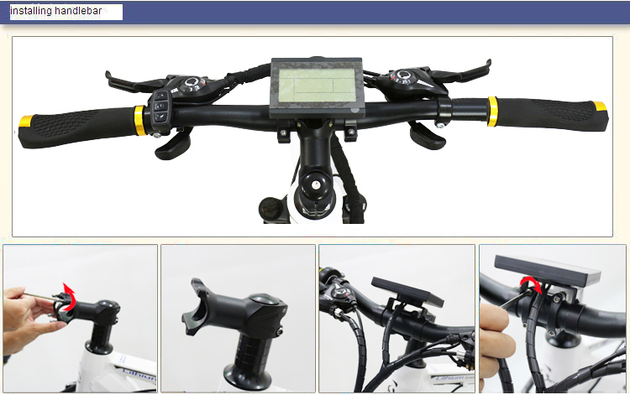

3.5 Assembly requirements
In order to ensure the cycling safety and performance, follow the fastening requirements for the bolts of key places:
Name of clamp bolts |  |  | Standard torque /N.m
Bolt for handlebar | 1 bolt / 2 bolts | M5 | 10-12 N.M
 |  | M6 | 12-15 N.M
 | 4 Bolts | M4 | 4-6 N.M
 |  | M5 | 6-8 N.M
 |  | M6 | 8-10 NM
Handlebar expander bolt |  | M6 | 12-15 N.M
 |  | M8 | 15-18 N.M
Handle bar stem and fork clamp bolt |  | M5 | 8-10 N.M
 |  | M6 | 10-12 N.M
Sunflower fixing bolt |  |  | 4-6 N.M
Saddle |  | M6 | 10-12 N.M
 |  | M8 | 15-18 N.M
Seat-pillar fixing bolt |  | M4 | 8-10 N.M
 |  | M5 | 10-12 N.M
 |  | M6 | 12-15 N.M
Front wheel |  |  | 25-30 N.M
Rear wheel |  |  | 40-45 N.M
Rear rack |  | M5 | 6-8 N.M
 |  | M6 | 8-10 N.M
Derailleur |  | M10 | 8-10N.M

4. Operation and adjustment
4.1 Introduction of PAS system
The PAS system is also known as 1:1 PAS system. And the so-called 1:1 automatic power assisting is that when you do not rotate the throttle but ride only by means of feet, the sensor will automatically sense your riding speed and control the motor to assist you automatically in a driving force with the same speed, so as to make your ride easier and make a longer range.

Operation of Your Display
There are 5 power-aid levels, the max speed is 25 Km/h,
LCD meter adopts the structural form with part design between the main part and operating buttons.
LCD meter adopts the structural form with part design between the main part and operating buttons.
There are three keys on the operating panel of button box, which are icons of button, button and
Hold button (SW) long, the meter is powered on and into normal operation, and it provides the controller with power supply. Under normal operating status, hold button (SW) long, the meter is powered off, meanwhile to shutdown the power supply of controllers. When the vehicle is stopped and without any button operation on the meter for five minutes, the meter will automatically shut down, and the power supply of the electric vehicle will be powered off. In power off mode, the power consumption of the meter and controller is zero.

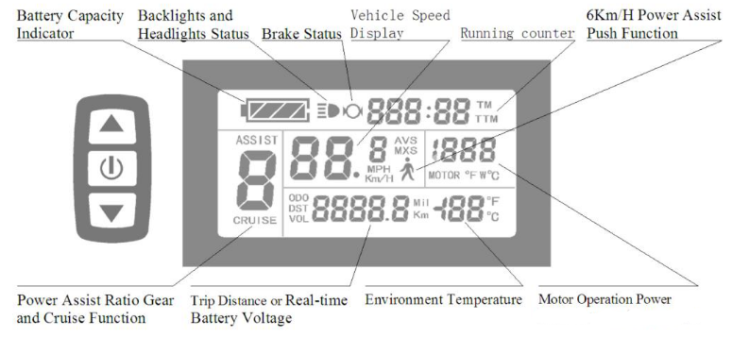
4.2 Charging
As it will last a certain period of time for the ex-factory, transport and storage of a new electric bike, it is likely to result in shortage of the battery power, the battery should be charged before it is used.
Please use the dedicated charger, otherwise it might damage the battery, and may even lead to fire disaster or other danger, then no warranty shall be provided by our company.
4.2.1 Installation and charging of battery
4.2.2 Charging steps and method
- Carefully check whether the rated input voltage of the charger is consistent with the supply voltage.
- The battery can be directly put on the bike for charging and can also be taken down from the bike to be charged indoors and at other appropriate places.
- Connect the output plug of the charger with the charging port of the battery and then connect the input plug of the charger with AC power supply.
- The power indicator of the battery and the charger are on, which means that the charging is connected.
- After charging, first pull out the input plug of the charger, then the output plug. It needs 6-8 hours for charging, when the indicator turns green instead of being red, then the battery is fully charged.
A new bike might well be recharged for 8-9 hrs after a deep discharging for the first time. It is to activate the active substances inside the battery. Later, it can be re-charged even if its power is not used up.
Common sense of charging and use:
The battery should be charged in a spacious environment, staying away from high temperature, high humidity and close fire, because the battery and the charger are electronic products, high temperature and humidity will corrode electronic components, resulting in some harmful gases or smog, and may even cause explosion.
The charging time should not be too long, or it may shorten life expectancy of the battery.
After the battery is fully charged, the power supply should be pulled out as soon as possible, and at the same time cut off the connection between the battery and the charger.
When the battery is not used for a long time, the battery power should be discharged till 50% power left, and it should be charged per month or so.
4.3 Reflection and lighting system
The reflection system includes a reflector on the rim, front and rear passive lamp, backpack, helmet and reflective patch on riding clothes.
The lighting system is mainly the battery or the self-power-generated front and rear lamp. These items help to mark your own position when riding at night, convenient for pedestrians and other vehicles on the roads to avoid.
(Tips: please abide by local laws and standards for the reflection and lighting system)

4.4 Safety height mark
4.5.1 Safety height mark of the stem
The stem can be properly adjusted depending on personal riding habit, but the safety mark cannot be exposed; It may cause serious injury in case of improper operation.
Adjustment method:
- Loosen the screw in the middle of the stem
- Move the stem to a certain height, and do not make the safety mark exposed.
- Fasten the screw.
4.5.2 Saddle position
When you sit on the saddle to tread on the pedal flatly by heel, when the pedal is at the lowest position, legs slightly stretch, and at this time it is the most suitable height; if the rider can tread on the pedal only by toes or legs cannot stretch slightly, fatigue and sports injury will be caused, so there is a careful need for adjustment of the height of the saddle post.
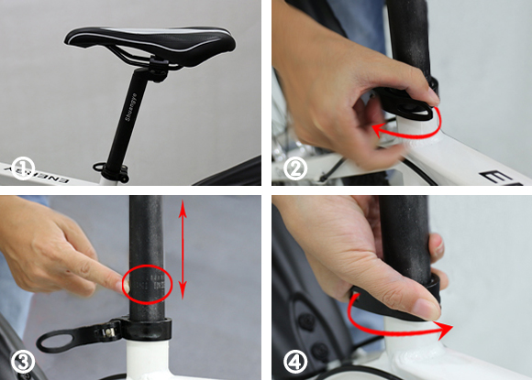
Adjustable Max position
The saddle post has a max mark line that is safety height mark which cannot be exposed. In case of improper use, serious injury may be caused.
Saddle angle: In order to avoid leaning forward when riding, it is appropriate for the front end of the saddle to lean upward, the front and rear position can be appropriately adjusted based on individual height.
Minimum height of the saddle: move the quick release handle to the OPEN position, then put the saddle post to the lowest place, and when the saddle post cannot enter into the saddle tube of the frame, it is the minimum height of the seat.
Maximum height of the saddle: move the quick release handle to the OPEN position, then lift the saddle post to the top but the safety line is not exposed, it is the maximum height of the saddle.
Measuring method: Place the bike perpendicular to the ground. The distance from the highest part of the curved surface of the saddle vertical to the ground is the height of the saddle.
4.6 Braking system
The braking system is an accessory necessary for each bike and is the key to traffic safety; before driving, you must understand your braking system, and do a good job in the inspection and adjustment work.
The general idea is that upon hard braking, the bike will surely stop in a short distance, but that is wrong. Upon hard braking, when the wheels are suddenly jammed by the brake rubber, the bike will glide horizontally, and it not only is dangerous but the braking distance will be lengthened. Therefore, the concept should be established is that the braking system is only used to adjust the speed of the bike.
The braking system typically includes a brake handle, brake (disc brake, V brake, and many other types of brakes) and brake cable.
The structure of the brake handle is as shown. The left brake handle controls the rear brake and the right brake handle controls the front brake.
The effective stroke of the brake cable is about a half of the distance between the brake lever and the grip.
When the distance between the brake shoe and the rim is too large, it is adjusted by the brake lever or the clamp.
When the brake cable or brake shoes are worn seriously, replace it timely in order to maintain traffic safety.
When riding in rainy days, the function of any gate device will be weakened, so please keep a longer safe braking distance and reduce the speed.
The surface on the brake disc, brake shoes cannot be oiled, so as to avoid serious damage.
If the brake cable is ripped, it may cause the brake cable to be broken and this is very dangerous, please replace timely.
4.7 Speed control system
The speed control system is used to cater for various terrain and clockwise and counterclockwise wind conditions, and to mix with physical strength appropriately.
The entire speed control system includes a derailleur, front and back fender, chain plate, and flywheel and shift cables.
The number of speed change series is the number of fluted disc×the number of flywheel pieces
For example: three pieces of chain plate × 7 flywheel pieces =21 speed change series and so on.
4.7.1 Derailleur
Type of derailleur: dial type (as shown)
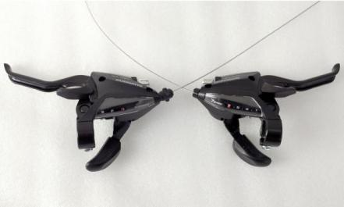
The derailleur is separately positioned on both sides of the handle, and the left controls the front one, the right controls the rear one.
4.7.2 Adjustment of the derailleur
The derailleur is classified into the front derailleur and back derailleur
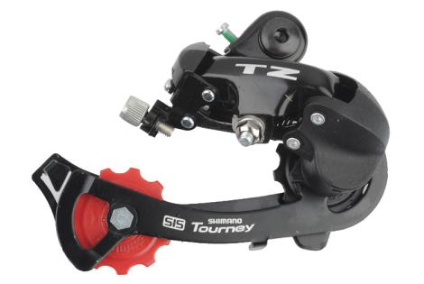
When the shift cables are loose or too tight, if the speed controller doesn’t work properly or the chain falls off, the H, L bolt is adjusted.
H bolt: when the chain speed changes to the biggest fluted disc, the chain will fall off, and the H bolt will be locked. But if it is too tight, the chain can’t climb to the biggest fluted disc.
L bolt: when the chain is toward the inside fluted disc and the chain falls off, the L bolt is locked. But if it is too tight, the speed change can’t be downward. Therefore it is appropriate to adjust the H, L bolt to a suitable position.
4.7.3 Chain
If the chain has not meshed with the chain wheel correctly, thus affecting the cycling performance, the chain should be timely adjusted.
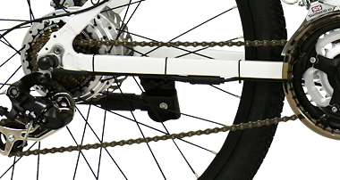
To determine the length of the chain: adjust the front derailleur to the lowest shift (the smallest tooth of the chain ring) and also adjust the back fender to the lowest shift ( the smallest tooth of the flywheel) to check whether the chain sag is more than 15mm (as shown). If it is more than 15mm, the chain is too long, please go to your supplier to shorten the chain in order to maintain the best cycling performance of your bike.
Common sense of the use of speed control system:
Do not tread reversely in the course of speed change so as not to lead to failure and the chain falls off.
As far as possible, do not change the gear-speed ratio substantially and should change the speed in accordance with the order.
If the electric bike is idle for a long time, the chain will be changed to the minimum keyboard tooth and the smallest flywheel, so as to avoid fatigue of the mechanical flexibility.
The chain, fluted disc, flywheel, derailleur should be always washed, wiped, and lubricated (oiled appropriately).
4.8 Damping system
Damping can keep the tire buffer contact with the ground when your bike is running on the uneven road so that the driver feels more comfortable while driving on the uneven road.
Damping hardness can be adjusted by adjusting the damping coefficient according to road conditions and personal preference.
Adjustment method of damping (as shown): rotate toward the “+” direction to increase the damping coefficient, thus increasing the damping hardness; rotate toward the “-“ direction to reduce the damping coefficient thus decreasing the damping hardness.

5. Use and maintenance
5.1 Routine inspection of electric bike before use
- Install the battery box in the slot of the battery box, open the power supply switch and check whether the functions of all the electrical appliances are normal.
- Safety inspection（see the notes to safe use in the Manual）
- Check whether the governor switch handle rotates and resets flexibly.
- Check whether the braking power-off function and braking effect are in good condition (braking distance on dry pavement : 4m, on wet pavement :15m)

5.2 Everyday use and inspection of electric bike
In everyday use of the electric bike, a number of mechanical, electrical parts will be worn, screws and other fasteners will loosen and the functions of the electrical appliances would be lost. If the occurrence of these phenomena is not noted, it is prone to failure, and it is also prone to the risk when cycling, so drivers must be responsible for routine inspection and maintenance.
5.3 Maintenance
In order to ensure traffic safety, from time to time, check whether all the electrical appliances work properly, whether there is any lost wire and whether mechanical parts are normal, and clean, wipe, oil the chain, fluted disc, flywheel and derailleur regularly (consult your supplier for the type of the oil product) so as to maintain the normal function of each part at any time.
6. Riding skills
A correct cycling posture is the premise of safety riding. The riding posture is closely related to the height and size of the cyclist. So a single-bicycle cycling posture not only determines the efficiency of muscle contraction movement, but at the same time determines whether the cyclist can manipulate the handle and brake safely. Therefore, a correct cycling position is key to be safe.
Safety riding skills
Adjust three parts of the E-bike to suit your body. The method of adjusting three parts is a combination of bicycle sports mechanics, exercise physiology and safety riding.
- Adjust the position of the seat: tread the pedal downward by heel to enable all muscle of the lower extremely joints contracts smoothly, and at the same time the principle is the legs can slightly stretch straight.
- Adjust the front and rear and the height of the handlebar: for the height of the handle, in general, the upwarping type handle is about 30-50mm higher than the seat, and the flat type handle is the same high as the seat. The top of the below curved type is the same height as the seat. After adjusting, pay attention to the direction of the handlebar and then lock.
*Sitting posture on the seat: Similar to the posture on horseback, the weight is scattered on the handle and pedals, and all the weight must not be placed above to prevent the pain in the hip.
*Skills of the pedal: The position of the foot is one third in the front of the length of shoes, and it is the most appropriate to fall on the middle of the pedal. Feet must be parallel with the centerline of the bike, and it will diminish the efficiency of the pedal if the feet are too open or narrow; the speed should maintain uniform, or else the rider may feel tired.
*Slowdown skills: the speed change gear slows down but doesn’t accelerate, as is to seek for the stability of the number of revolutions of the pedal, so as to relieve the fatigue arising from uneven force. So, the speed change is used for more labor-saving and comfortable.
The time for speed change is: 1. Climbing, 2. Uneven pavement. 3. Against the wind. 4. When feeling tired. It can also be said the time is when feeling not comfortable during the riding.
*Braking skills: as we all know the principle of hard braking is first stopping the rear brake then the front brake. But in case of an emergency, everyone will stop all together. If the braking distance is appropriate, the bike can stop securely. If the slowdown is too fast, people often would be thrown forward and in order to prevent this danger, the best way is intermittent braking, and meanwhile the hip is pushed backward. In rainy days, increase the braking distance due in safety and reduce the speed.
7. Troubleshooting
 | Problems | Cause | Methods
1 | Failed speed change or too low maximum velocity | - Low battery voltage  - Throttle failure  - Controller failure | - Fully charge the battery  - Replace throttle or controller
2 | Turn on the power supply, but the motor doesn’t work | - Throttle failure  - Lock failure or poor electric contact | - Replace throttle or controller  - Re-welding contact parts
3 | Short range | - Low tire pressure  - Inadequate charging or charger failure  - The battery is damaged or its life has expired  - Frequent braking start up, overloading | - Pump up the tire  - Charge the battery or replace a charger  - Replace the battery
4 | The charger doesn’t work | - Charger wiring is loose or damaged  - The battery weld line falls off or is damaged | - Welding the connect line or replace the charger  - Welding the connect line or replace the battery
5 | No power assistance | - Sensor damage  - PAS cable damage | - Replace the sensor plate  - Replace the cable

